Big 3 Warm Up 11/20

Word of the Day

Undulate: Verb
- Move in a wavy pattern or with a rising and falling motion.
- Stir up (water) so as to form ripples.
Underline the Word and Use it in a sentence.

World History/Government Trivia:
When was the Bill of Rights ratified?
What date?

Picture Response:
Who is this? Hint-Considered “Author” or “Father” of the Bill of Rights.

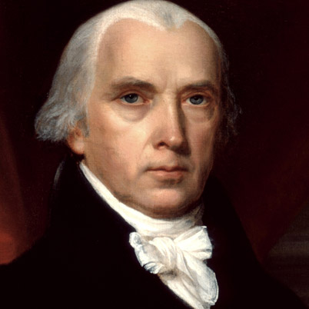

Quote of the School Year:
“Actions speak louder than words.”

December 15, 1791

Picture Response
James Madison

