Big 3 Warm Up 11/10

Word of the Day: Consensus

Noun

1a : general agreement : unanimity <the consensus of their opinion, based on reports … from the border — John Hersey>
b : the judgment arrived at by most of those concerned <the consensus was to go ahead>

2: group solidarity in sentiment and belief

Ex: There is a lack of consensus among the citizens.

World History/Government Trivia

By the end of the 19th century, this city built the first Subway System in the United States. Name the city.

Picture Response

Write two to three sentences based off the historic image.

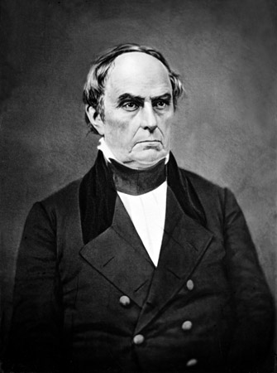

Quote of the Day
History is a relentless master. It has no present, only the past rushing into the future. To try to hold fast is to be swept aside.

Boston

