Big 3 Warm Up 5/01

Word of the Day:

Pry • verb
1. to move or force, especially in an effort to get something open
2. search or inquire in a meddlesome way
3. make an uninvited or presumptuous inquiry
Example Sentence: Production costs? Reporters have to pry estimates out of sources.
Video Using the Word Pry:
https://youtu.be/D7UfDns8Eao

8th Grade Social Studies Trivia:

Question 1: Thirty-six columns surround the Lincoln Memorial. What do they represent?
Question: 2 In 1965, when President Lyndon B. Johnson underwent surgery, his Vice President served as acting President of the United States for exactly three hours. Who was this Vice President, and what kind of surgery ?

Picture Response:

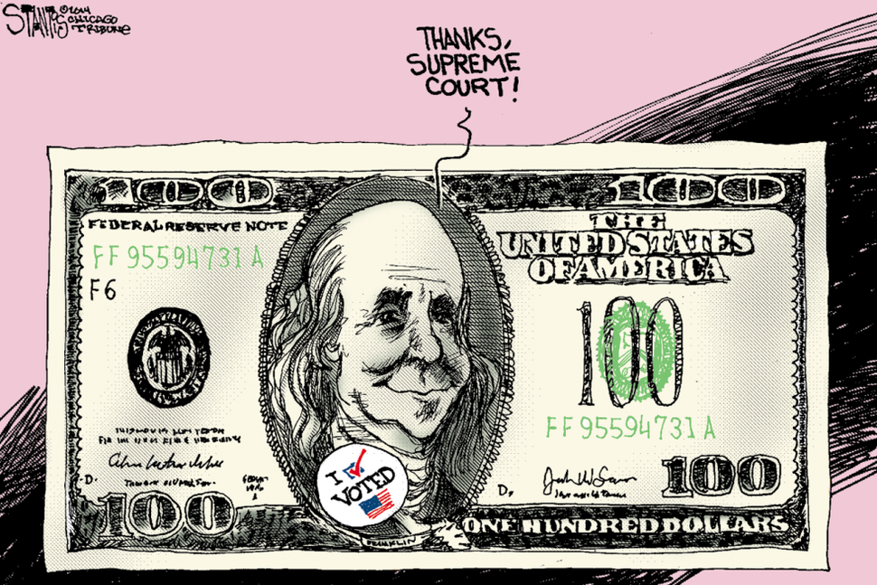

36 U.S. STATES AT TIME OF LINCOLN'S PASSING
HUBERT HUMPHREY / GALL BLADDER

