Big 3 Warm Up 3/06

Word of the Day: Imperialism
Noun

Definition:
A policy of extending a country's power and influence through diplomacy or military force.

Example Sentence: British imperialism created the enormous British Empire in the 19th and 20th centuries.

Use the word of the day in a sentence and underline the word.

8th Grade Social Studies Trivia:

This was considered first great civil engineering project in the United States. It revolutionized the New York and Midwest economies and New York City secures its role as America's commercial capital. What canal am I speaking of?

Picture Response:

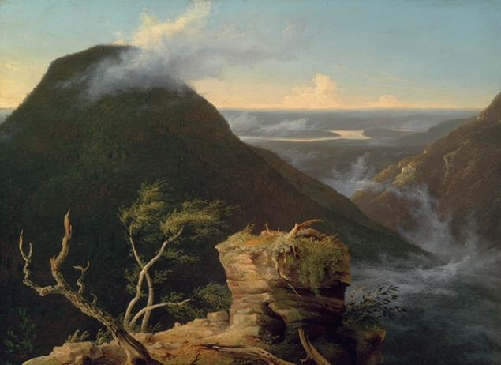

Write a two to three sentence interpretation of this historic painting

Quote of the Day:
“Actions speak louder than words.”

The Erie Canal

