Big 3 Warm Up 03/04

Word of the Day: Predecessor

Noun

Definitions:
A person who held a job or office before the current holder.
A thing that has been followed or replaced by another.

Example Sentence: The new President's foreign policy is very similar to that of his predecessor.

8th Grade Social Studies Trivia

Independence Day was first established as a holiday by Congress in what year?

Picture Response

Write two to three sentences based off the historic painting.

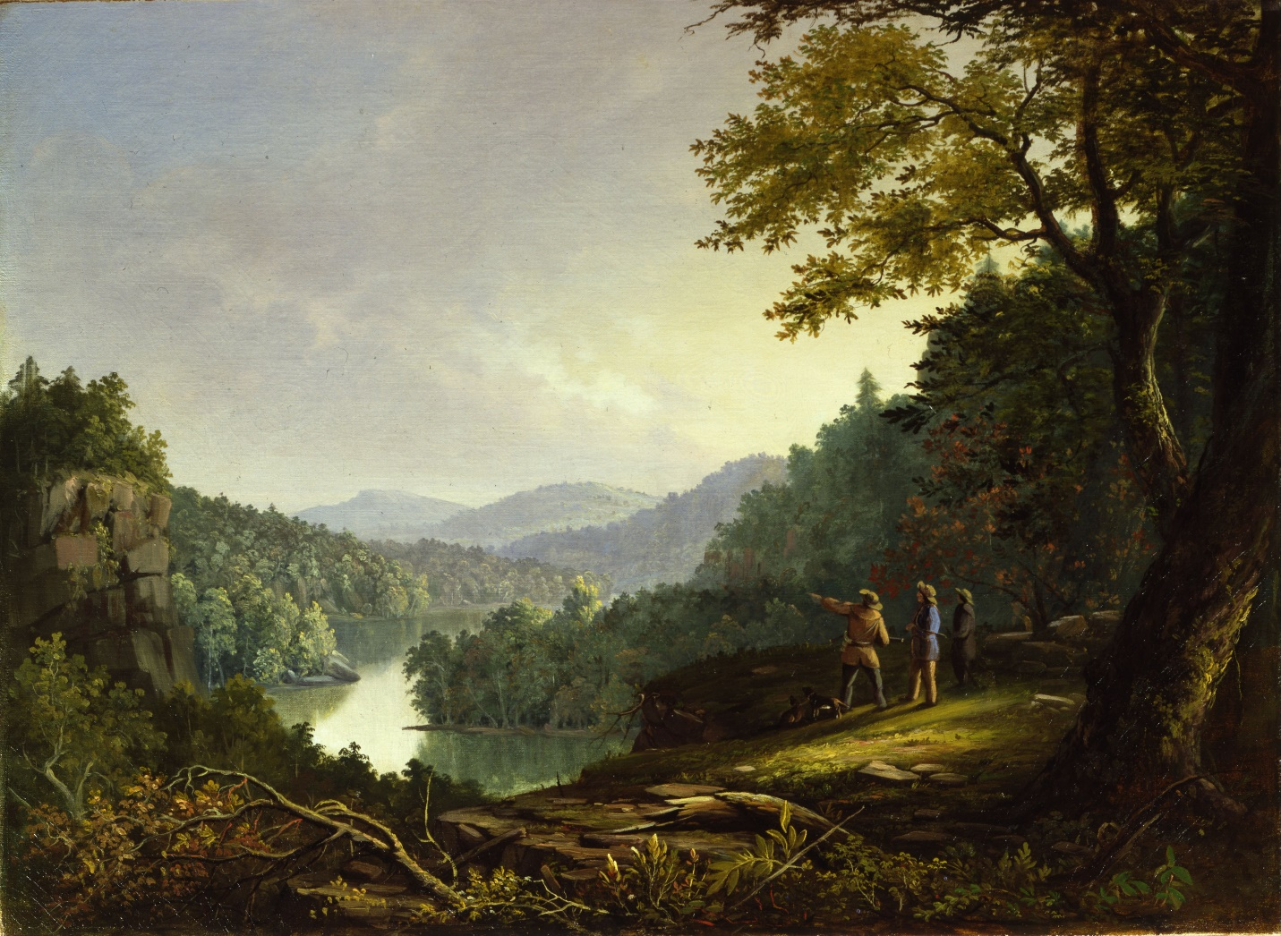

Quote of the Day
The best way to guarantee a loss is to quit.

Congress proclaimed the Fourth of July a national holiday in 1870, and in 1938 it was established as a paid holiday for federal employees.

