Big 3 Warm Up 03/25

Word of the Day:

Per se, adverb:
Definition: with respect to its inherent nature

Example Sentence: It is not these facts per se that are important.

Use the word of the day in a sentence and underline the word.

8th Grade Social Studies Trivia:

Andrew Jackson was the President of the United States when the plans for the 'Trail of Tears' were made but who was president when it actually took place?

Picture Response:
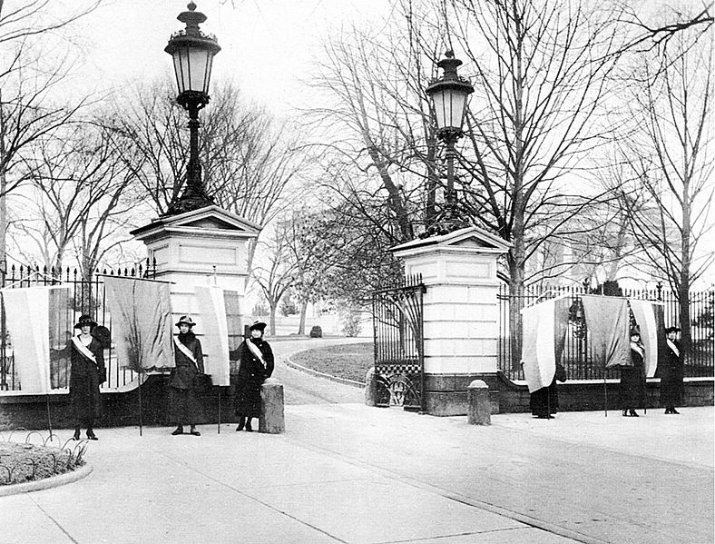

Write a two to three sentence interpretation of this historic painting

Quote of the Day:
“Actions speak louder than words.”

Martin Van Buren

