**Big 3 Warm Up 03/10**

**Word of the Day:** Bellwether *noun*

Definition:

1. One who leads a group
2. A person or thing that sets a trend

Synonyms**:** trendsetter

Example Sentence:

New York fashion shows are frequently a bellwether for styles that later sweep the country.

Use the word of the day in a sentence and underline the word.

**World History/Government Trivia:**

1. What company raised the pay of its employees 40 percent despite the collapse of the

U.S. stock market in December of 1929? This company’s employee’s wages went

from $5 to $7 a day.

2. **In 1931, what person** became a co-recipient of the Nobel Peace Prize, thus being the

first American woman to receive the prize?

**Quote of the Day:** “The best thing about the future is that it comes only one day at a time.”

- **Abraham Lincoln**

**Picture Response:**

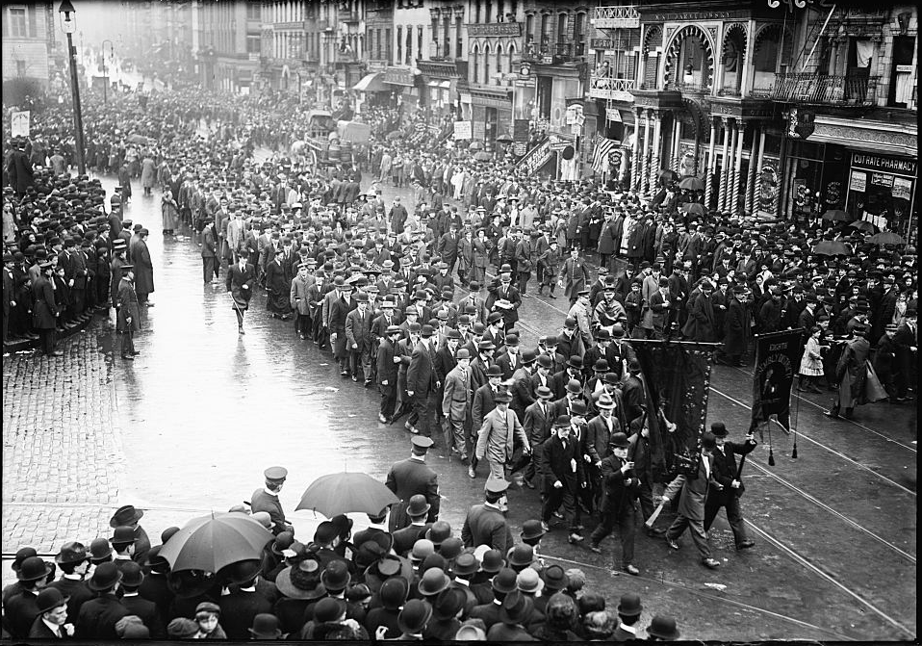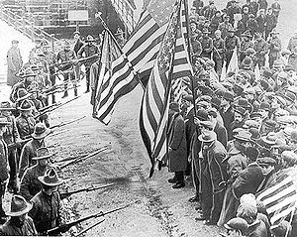

**Write a two to three sentence interpretation of this historic pictures**

**A:** Ford Motor Company

**A:** Jane Addams