Big 3 Warm Up 01/31

Word of the Day:

Brook noun
Defintion: a natural stream of water smaller than a river (and often a tributary of a river)

8th Grade Social Studies Trivia:

Jefferson entered the College of William & Mary in Williamsburg at what age?

Picture Response:

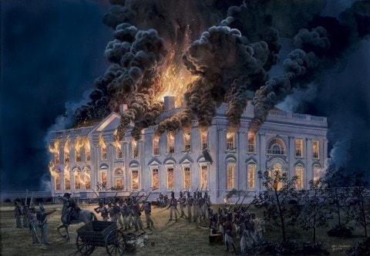
Write a two to three sentence response

A: At age 16.

https://www.triviaplaying.com/492-Thomas-Jefferson-presidential.htm

