Big 3 Warm Up 1/30

Word of the Day:

Fluke • noun

Definition
1. A stroke of luck

Use the word of the day in a sentence and underline the word.

8th Grade Social Studies Trivia:

When the British burned the Library of Congress in 1814 Thomas offered to do what?

Picture Response:

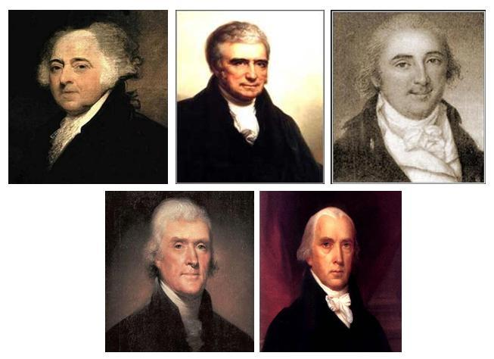

Write a two to three sentence response

Quote of the Day:
“Actions speak louder than words.”

A: Sell his collection of more than 6,000 books to the Library of Congress for $23,950.

