**Big 3 Warm Up 1/29**

**Word of the Day:**

**Hibernate verb**

**Definitions**

**1.**Be in an inactive or dormant state

**2.**Sleep during winter

Use the word of the day in a sentence and underline the word.

**8th Grade Social Studies Trivia:**

What five languages did Thomas Jefferson speak other than English?

**Picture Response:**

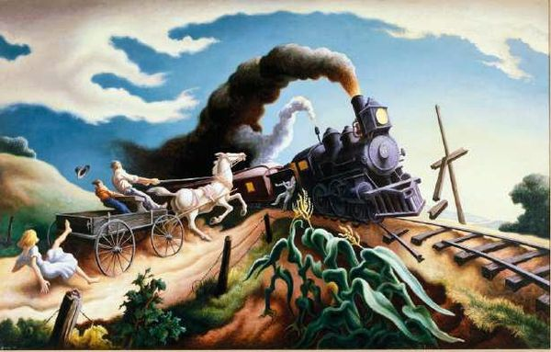

**Write a two to three sentence response**

**Quote of the Day:**

**“Actions speak louder than words.”**

A: French, Greek, Italian, Latin, and Spanish.