Big 3 Warm Up 1/28

Word of the Day:
Intellect noun

Definitions:
1. Knowledge and intellectual ability
2. The capacity for rational thought or inference or discrimination
3. A person who uses the mind creatively

Use the word of the day in a sentence and underline the word.

8th Grade Social Studies Trivia:

In May 1785, Thomas Jefferson became the United States Minister to what European country?

Picture Response:

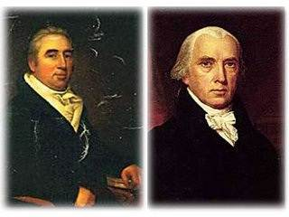

Write a two to three sentence response

Quote of the Day:
“Actions speak louder than words.”

A: France.

