Big 3 Warm Up 01/25/19

Word of the Day:
Boycott

Verb
Definition(s):
To engage in a concerted refusal to have dealings with (a person, a store, an organization, etc.) usually to express disapproval or to force acceptance of certain conditions
Example Sentence:
The American government boycotted Chinese steel over disputes of exports and imports due to the ongoing tariff war between the two countries.
Use the word of the day in a sentence and underline the word.

8th Grade Social Studies Trivia:

The official reason given by President Madison for the Declaration of War in 1812 were mainly concerned with:
- Trouble with France
- Conflict with Spain.
- Ongoing problems at sea between American and British vessels.
- Personal reasons.

Picture Response:
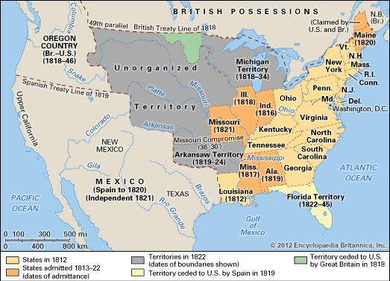

Write a two to three sentence interpretation of this painting

Quote of the Week:
“Preparation and the willingness to review and study for an upcoming exam is the key to success.”
- Mr. Kay

A: b. The Declaration of Independence

A: D. new grain crops developed in the Green Revolution

