Big 3 Warm Up January 24th

Word of the Day:

Objective

Definition: Dealing with observable facts rather than opinions or interpretations.

Use the word of the day in a sentence that you have created and underline the word of the day in order to receive full credit.

Example sentence: When a legal case involves a shocking crime, it may be hard for a judge to remain objective in his rulings.

8th Grade Social Studies Trivia:

The American Revolution officially comes to an end when representatives of the United States, Great Britain, and (blank) two countries signed the Treaty of Paris on this day in 1783. What are these two countries?

Picture Response:

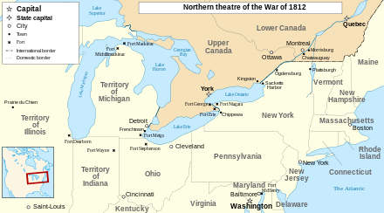

Write at minimum two to three sentences on what you are seeing in this historical painting.

Quote of the Day:
“Actions speak louder than words.”

