Big 3 Warm Up 10/29

Word of the Day: Penchant

Noun

A strong liking for something or a strong tendency to behave in a certain way

Example Sentence: From both her father and mother she had inherited a penchant for art, literature, philosophy, and music. Already at eighteen she was dreaming of painting, singing, writing poetry, writing books, acting—anything and everything.

8th Grade Social Studies Trivia:

Who were are first three presidents of the United States of America?

Picture Response

Write a two to three sentence interpretation of the image.

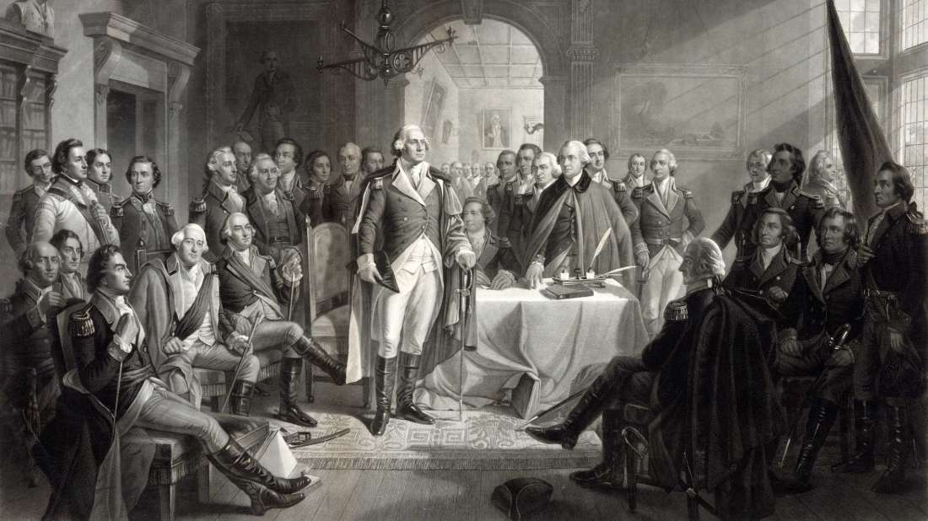

Quote of the Day
“Those who do not remember the past are condemned to repeat it.”

Coffee

