Big 3 Warm Up 03/30

Word of the Day:

Definition:
Fabricate, verb:
1. to make, build, or construct
2. to make up, invent
3. to fake or forge a document or signature

Example Sentence: "I've had more people tell me that throughout my career: 'Man, we love to watch you play. Your enthusiasm and stuff like that.' I mean, it's not fabricated. I love to play the game …"

Use the word of the day in a sentence and underline the word.

World History/Government Trivia:

Of the 32 civil rights cases Thurgood Marshall argued before the U.S. Supreme Court as the lawyer for the National Association for the Advancement of Colored People, how many did he win?

Picture Response:
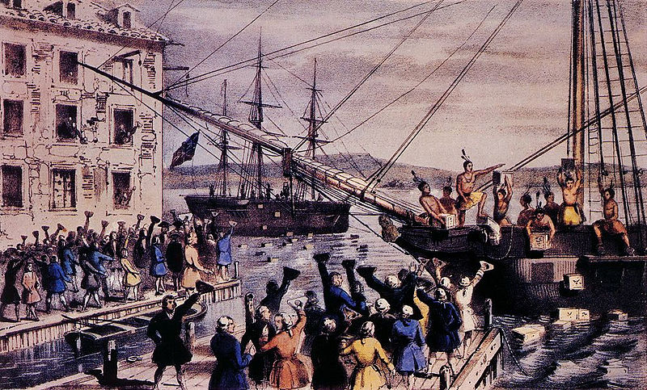

Write a two to three sentence interpretation of this historic painting

Quote of the Day:
“Actions speak louder than words.”

29

