Big 3 Warm Up 03/01 (2nd set of Big 3 Warm Ups due today)

Word of the Day:

Permanent

Definition: continuing or enduring without marked change in status or condition or place

Example Sentence: Think twice about writing in permanent marker or getting a tattoo because both are just about impossible to erase.

Please write a sentence using the word of the day. Underline the word of the day in your sentence.

World History/Government Trivia:

What is the most common first name for a president or some variation of it?

Picture Response:
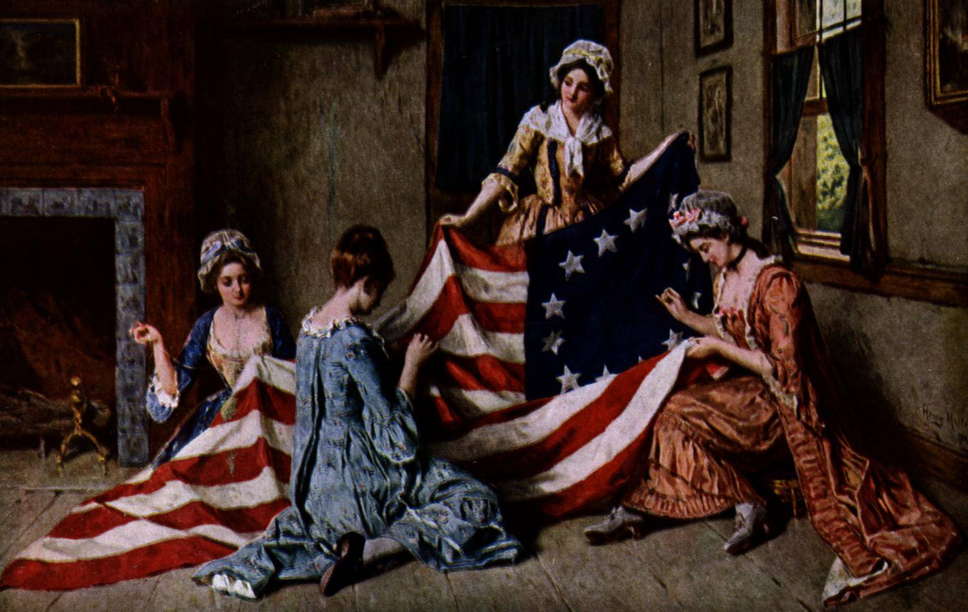

(In order: James Madison, James Monroe, James Polk, James Buchanan, James Garfield, Jimmy Carter)

James

