Big 3 Warm Up 03/19

Word of the Day:
Gloaming, noun:
Definition: Twilight; dusk.

Example Sentence: The children squealed and waved and smiled, their teeth flashing white in the gloaming.

Use the word of the day in a sentence and underline the word.

World History/Government Trivia:

What was the powder used by America's Founding Fathers to keep their wigs white?

Picture Response:
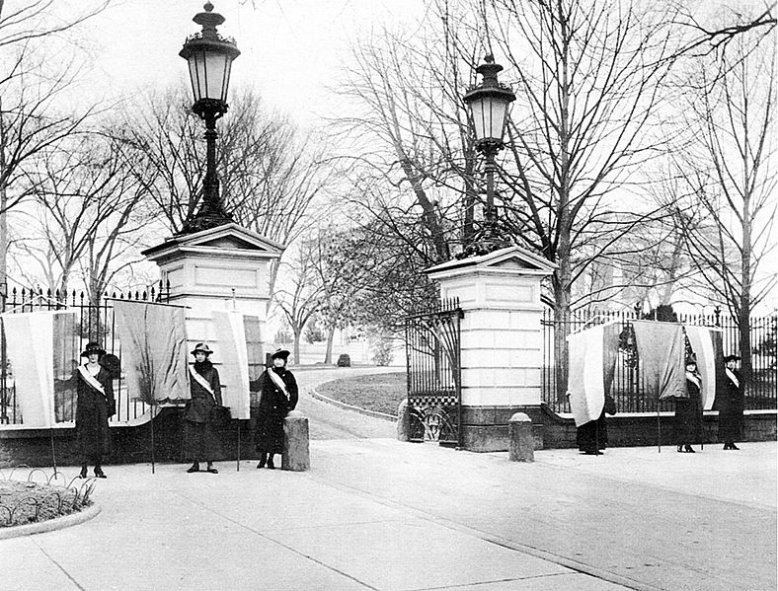

Write a two to three sentence interpretation of this historic painting

Quote of the Day:
“Actions speak louder than words.”

Ground Rice

