Big 3 Warm Up for Thursday 01/07/16

## Word of the Day: TRIFLING

Definition(s):

Minor

Example Sentence:

"A stubbed toe is a trifling medical problem compared to a broken leg."

Use the word of the day in a sentence and underline the word.

**Government Trivia:**

After the original 13 colonies, which were the next three states admitted to the Union?

a. Alabama, Louisiana, Mississippi   
b. West Virginia, Alabama, Florida   
c. Vermont, Kentucky, Tennessee

**World History Trivia**

The North and South American independence movements of the late eighteenth and early nineteenth centuries shared which of the following?

(A) Revolutionary demands based on Enlightenment political ideas

(B) Reliance on Christian teachings to define revolutionary demands

(C) Industrial economies that permitted both areas to break free of European control

(D) Political instability caused by constant warfare among the new states

**Picture Response:**

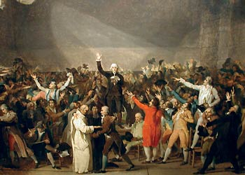

**Oath of the Tennis Court**

In 1789, King Louis XVI (the Sun King's great-great-great-grandson) called an assembly of representatives. As a result, the National Assembly formed, made up of what was the "Third Estate." After King Louis XVI refused to let the National Assembly convene in an official venue, they met at a tennis court instead

**Write a two to three sentence interpretation of this painting**

**Quote of the Week:**

“Preparation and the willingness to review and study for an upcoming exam is the key to success.”

- Mr. Kay

**A:** c. Vermont, Kentucky, Tennessee

**A: (A) Revolutionary demands based on Enlightenment political**

**ideas**