Big 3 Warm Up 02/02

Word of the Day:

Gerrymander •verb and noun

Verb: divide unfairly and to one’s advantage; of voting districts
Noun: an act of gerrymandering (dividing a voting area so as to give your own party an unfair advantage)

Use the word of the day in a sentence and underline the word.

World History/American Government Trivia:

What President of the United States of America could write Latin with one hand and Greek with the other – simultaneously?

Picture Response:

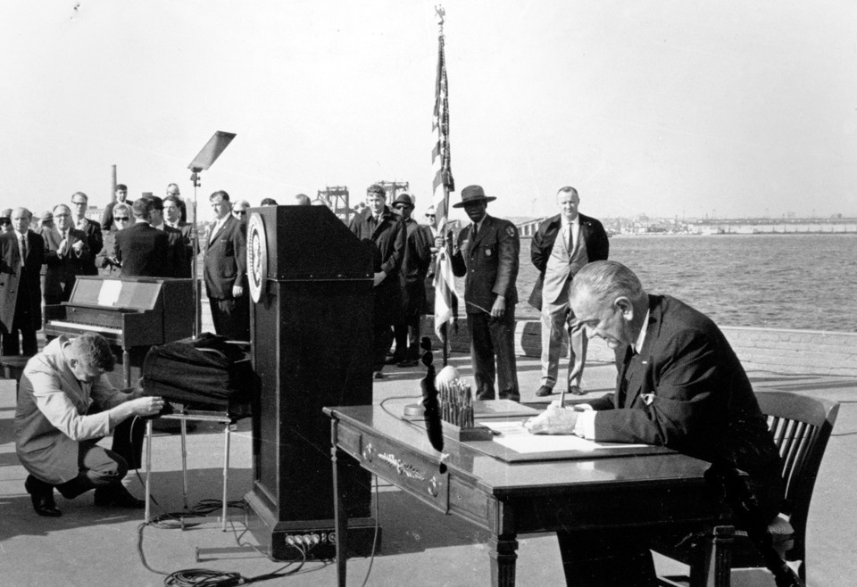

Quote of the Day:
“Actions speak louder than words.”

President James Garfield

