**Big 3 Warm Up 12/06**

**Word of the Day: Alleviate verb**

Definition(s):

1: relieve, lessen: as

2**:** to make (as suffering) more bearable

3**:** to partially remove or correct

Example Sentence:

Public health officials are pushing to alleviate crowds at Detroit's emergency rooms by redirecting patients without life-threatening ailments to one of the city's 25 community health centers.

Use the word of the day in a sentence and underline the word.

**8th Grade Social Studies Trivia:**

1. Who was the first and only American President to resign from office?

2. What was Al Capone eventually imprisoned for?

**Picture Response:**

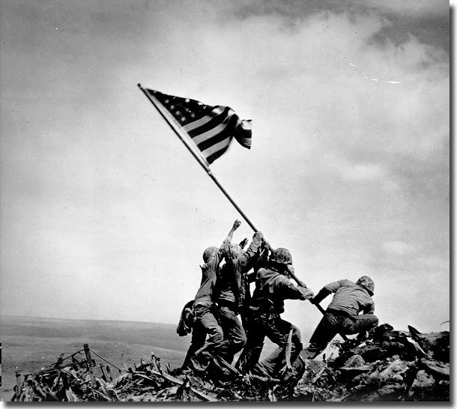

**Write a two to three sentence interpretation of this historic picture**

**Quote of the Day:** “The best thing about the future is that it comes only one day at a time.”

- **Abraham Lincoln**

**A:**  Richard Nixon

A: Tax evasion. Convicted of income tax evasion in 1931 and sentenced to 11 years in prison, he was released on parole in 1939.