**Big 3 Warm Up for 12/05**

## Word of the Day:

**Misrepresent (verb)**

Definition(s):

To present in an inaccurate, false, or unfair fashion.

Example Sentence:

The senatorial candidate accused her opponent of misrepresenting her position on several important issues.

Use the word of the day in a sentence and underline the word.

**American History/Government Trivia:**

### 1.  The _________ violated privacy rules protecting the communications of Americans and others on domestic soil 2,776 times over a one-year period, according to an internal audit leaked by the former N.S.A. contractor Edward J. Snowden and made public on Aug. 15. An official there said many were unintentional human or computer errors, and called the number of willful errors “minuscule.”

**Picture Response:**

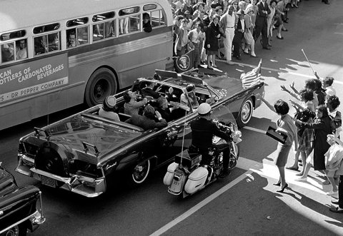

**Write a two to three sentence interpretation of this painting**

**Quote of the Day:**

[“I am a success today because I had a friend who believed in me and I didn't have the heart to let him down...”](http://www.quotesdaddy.com/quote/288/abraham-lincoln/i-am-a-success-today-because-i-had-a-friend-who-believed)

- Abraham Lincoln

**A: National Security Agency**

Read ["N.S.A. Often Broke Rules on Privacy, Audit Shows"](http://www.nytimes.com/2013/08/16/us/nsa-often-broke-rules-on-privacy-audit-shows.html)

**A:**  Richard Nixon

A: Tax evasion. Convicted of income tax evasion in 1931 and sentenced to 11 years in prison, he was released on parole in 1939.