Warm Up for December 19th

Word of the Day:
Vehement \VEE-uh-muhnt\ , adjective:

Definitions:

1. Characterized by intensity of emotions or convictions, or forcefulness of expression.

2. Characterized by or acting with great force or energy; strong

Example sentence:

Vehement cries of "No! no! never!"

Use the word of the day in a sentence and underline the word.

Trivia:
1. Who was the director of the CIA from 1976-81?
2. How many vice presidents did Franklin D Roosevelt have?

Picture Responses:

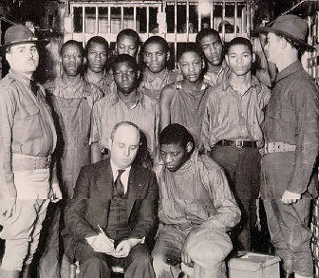

Write a two to three sentence interpretation of this historic painting

Answers:
1. George Bush
2. 3

