Big 3 Warm Up 02/27

Word of the Day: Alias

Adverb

Otherwise called: otherwise known as

Example Sentence: Samuel Clemens used the alias Mark Twain when he wanted to write books.

World History/Government Trivia

This holiday has a law in place so that no President can change the date after the national outrage caused one President to reverse his decision. Name the Holiday.

Picture Response

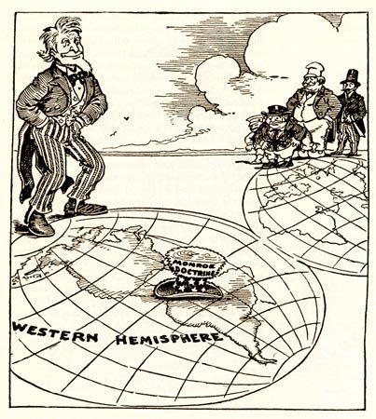

Write two to three sentences based off the historic painting.

Quote of the Day

Difficulty is the excuse history never accepts.

Thanksgiving

