Big 3 Warm Up 2/13

Word of the Day:

Barter

Definition: exchange goods without involving money

EXAMPLE SENTENCE:
However, a great deal of diplomacy in establishing allies, bartering land, and signing peace treaties was necessary for each warring state, and the idealized role of the "persuader/diplomat" developed.

Please write a sentence using the word of the day. Underline the word of the day in your sentence.

8th Grade Social Studies Trivia:
Who was the last surviving signer of the U.S. Constitution?

Picture Response:

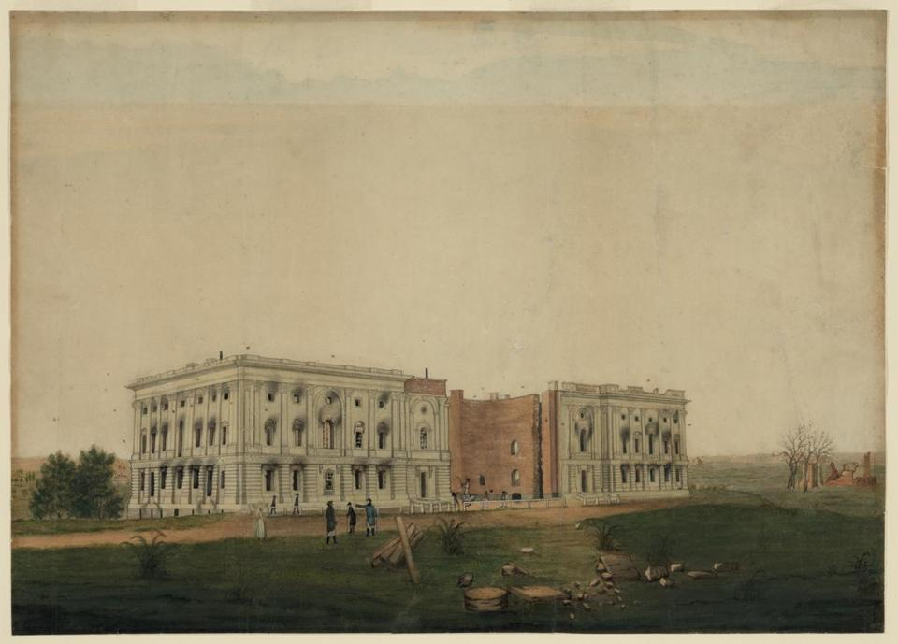

Your response must be at least two sentences in length.

James Madison

