Big 3 Warm Up 02/06

Word of the Day:

Plagiarize • verb
Take without referencing from someone else’s writing or speech; of intellectual property

Use the word of the day in a sentence and underline the word.

8th Grade Social Studies Trivia:
What was the objective of the Lewis and Clark expedition?

Picture Response:
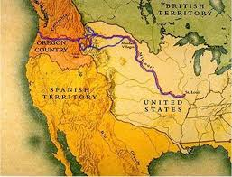

A: It was to explore and map the newly acquired territory, and establish an American presence before Britain and other European powers tried to claim it.

Quote of the Day:
“Actions speak louder than words.”

