Big 3 Warm Up 02/23

Word of the Day:

Bigotry • noun

Definition: the intolerance of a prejudiced person

Use the word of the day in a sentence and underline the word.

World History/Government Trivia:

Before this U.S. president, no left-handed American president had ever served two terms. Who is this president?

Picture Response:

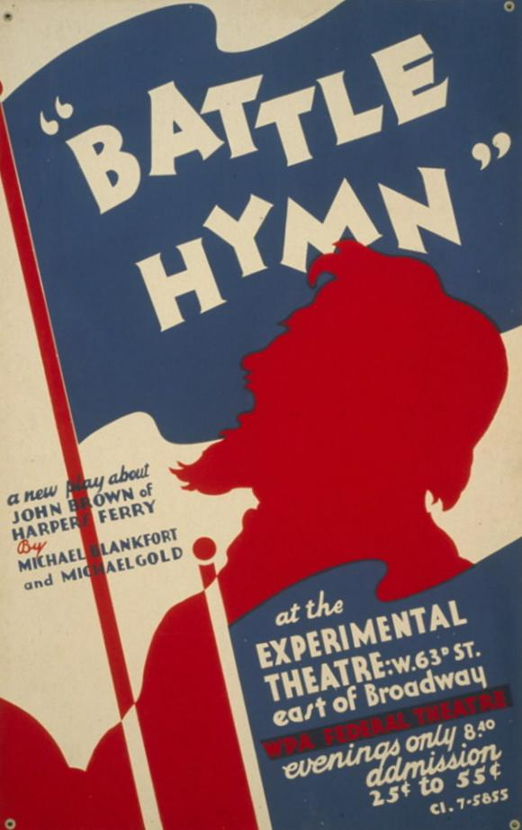

Question 1: When was the play written?

Question 2: Which two of the facts below might help explain why the authors wrote this play?

1. Slaves made up nearly 40% of Virginia’s population in 1859.
2. One of the play’s authors, Michael Gold, was a member of the Communist Party, which protested against lynching in the 1930s.
3. After taking power in 1933, Adolf Hitler enacted racist policies in Germany.
4. After seceding from the Union in 1861, Virginia became the largest state in the Confederacy and the home of its capital, Richmond.

Quote of the Day:
“Actions speak louder than words.”

William Clinton

