**Big 3 Warm Up 02/11**

**Word of the Day:**

### Perceptive • adjective

**1.** of or relating to perception  
**2.** having the ability to perceive or understand; keen in discernment

Use the word of the day in a sentence and underline the word.

**World History/Government Trivia:**

This U.S. President was the only man who held both the Presidency and the Vice-Presidency but who was not elected to either post. Who was this U.S. President?

**Picture Response:**

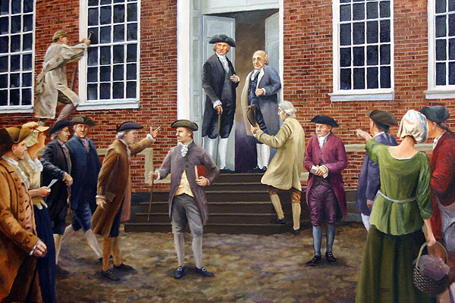

**Quote of the Day:**

**“Actions speak louder than words.”**

Gerald Ford