Big 3 Warm Up 04/30

Word of the Day:

Burden (noun)
Definition: A load; something which is borne or carried with difficulty.

Example Sentence: After staying with her friend for three weeks, Sarah began to feel she was becoming a burden and so decided to find a place of her own.

Use the word of the day in a sentence and underline the word.

World History/Government Trivia:

After the Civil War the U.S. sued which country for damages that were caused by them building ships for the Confederacy? We originally asked for $1 billion but settled on $25 Million.

Picture Response:

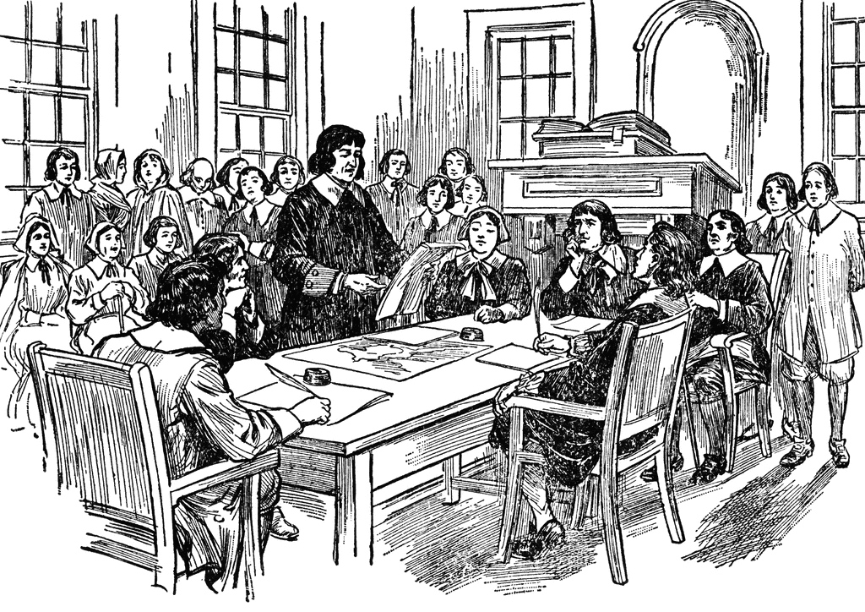

Write a two to three sentence interpretation of this historic painting

Great Britain
Quote of the Day:
“Actions speak louder than words.”

