Big 3 Warm Up 04/29

Word of the Day:
Rubric, noun:
Definitions:
1. A title, heading, or the like, written or printed in red or otherwise distinguished from the rest of the text.
2. A direction for the conduct of divine service.
3. Any established mode of conduct or procedure.

Example Sentence: In our office, we have a file of rubrics The New Yorker has used in its eighty-five-year history

Use the word of the day in a sentence and underline the word.

World History/Government Trivia:

Louisa (blank), wife of a U.S. President, was the first (and only) foreign-born first lady. Who was she the wife of?

Picture Response:

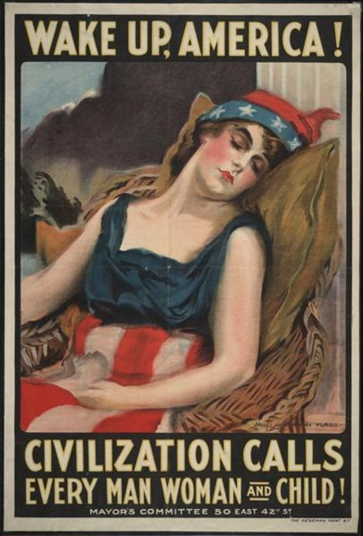

Write a two to three sentence interpretation of this historic painting

John Quincy Adams
Quote of the Day:
“Actions speak louder than words.”

