**Big 3 Warm Up 2/11/13**

**Word of the Day:**

[**initiative**](http://www.vocabulary.com/dictionary/initiative)

Definition: readiness to embark on bold new ventures

EXAMPLE SENTENCE:

Russia is open to new joint **initiatives** in this sphere.

Please write a sentence using the word of the day. Underline the word of the day in your sentence.

**Government Trivia:**

The (blank) Party has been known as the G.O.P., or Grand Old Party, since around 1880. Although no one knows the exact origin of the moniker, many people think it was taken from the nickname of British Prime Minister William Gladstone. He was known as the Grand Old Man, or G.O.M.

**Picture Response:**

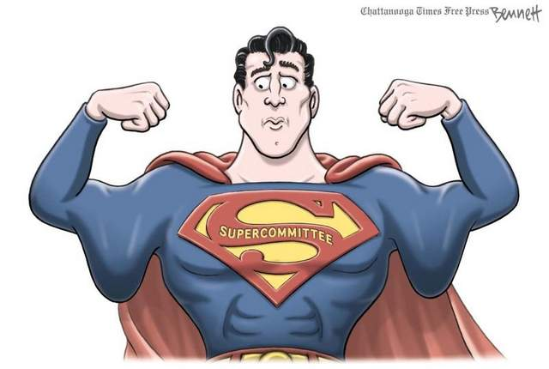

Republican