**Big 3 Warm Up 2/25**

**Word of the Day:**

[**Facilitation**](http://www.vocabulary.com/dictionary/facilitation)

Definition: act of assisting or making easier the progress or improvement of something

Example: If you volunteer to help with the facilitation of enrolling new students at a school, you might be by the door, handing out forms and directing families to the main office.

Please write a sentence using the word of the day. Underline the word of the day in your sentence.

**World History/Government Trivia:**

The Civil War’s direct cost was about how much in 1860 money, which would be $139 billion today. However, some economic historians believe the indirect cost (such as disruption of the economy) would measure approximately $46 trillion in current money.

**Picture Response:**

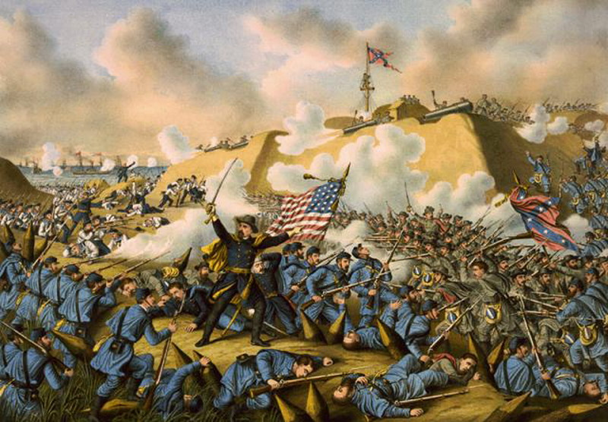

$6.7 billion