**Big 3 Warm Up 1/26**

**Word of the Day:**

### Ingenuous •adjective

1. lacking in sophistication or worldliness
2. characterized by an inability to mask one’s feelings; not devious

Underline the word and use it in a sentence that you created.

**American Government/World History Trivia:**

What was the first country to recognize the United States in 1776?

Name that Country

**Picture Response:**

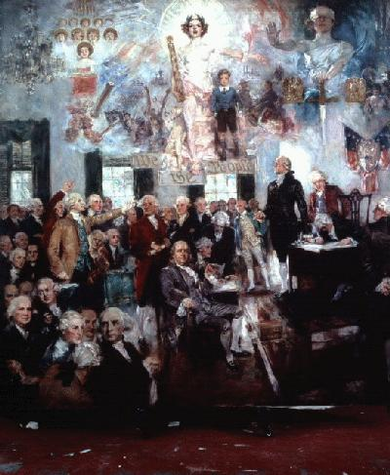

**(Example of student response)**

Responses will vary

**Quote of the School Year:**

**“Actions speak louder than words.”**

Example of the word of the day used in a sentence

Charlie Bronson has the same **ingenuous** puppy-dog stare of a naughty boy playing dumb, and the same vacant, toothy grin and Owen Wilson drawl as Crosby, but none of the depth.

Answer to the trivia question of the day

Croatia was the first country to recognize the United States in 1776.