Big 3 Warm Up 11/02

Word of the Day:
Peregrination/noun

Definition(s):
1. Travel from one place to another, especially on foot.
2. A course of travel; journey.

Example:
Each step he took represented an inward peregrination.

Use the word of the day in a sentence and underline the word.

History/Government Trivia:

- Which three states did the USA gain after the Mexican war?
- In which year did the Japanese attack Pearl Harbor?

Picture Response:

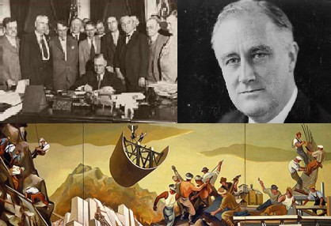

Write a two to three sentence interpretation of this historic painting

1941
New Mexico, California, and Texas
Quote of the Day:
“Actions speak louder than words.”

