Big 3 Warm Up 10/11

Word of the Day:
Hacienda \noun:

Definition: A large estate, especially one used for farming or ranching.

Example Sentence: He gritted his teeth and turned his stallion's head toward the hacienda.

Use the word of the day in a sentence and underline the word.

History/Government Trivia:

Eighty-seven-year-old Democrat Rebecca Latimer Selton held what distinction in the political arena?

Picture Response:
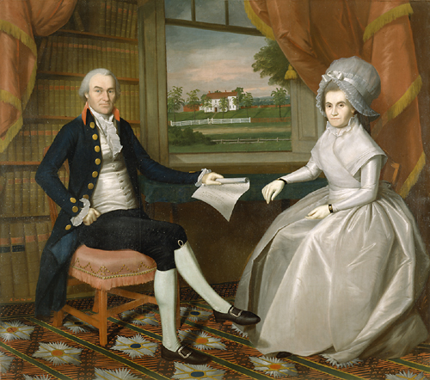

Write a two to three sentence interpretation of this historic painting

She was the first woman to become a U.S. Senator, when she was appointed by the governor of Georgia to serve the remaining day of a vacated Senate seat, November 21-22, 1922.

Quote of the Day:
“Actions speak louder than words.”

