Big 3 Warm Up 10/10

Word of the Day:
Moot\adjective:

Definition:
1. Open to discussion or debate; doubtful.
2. Of little or no practical value or meaning; purely academic.

Example Sentence/Quote: “What do you mean, ‘moot'?” “I mean moot. It's taken care of. The documents are notarized. I'm recouping my lawyer's fees and that's the end of it.”

Use the word of the day in a sentence and underline the word.

History/Government Trivia:

John Jay, John Marshall, Roger B Taney, and Salmon P. Chase were all chief justices of the U.S. Supreme Court. However, what did they all not attend?

Picture Response:
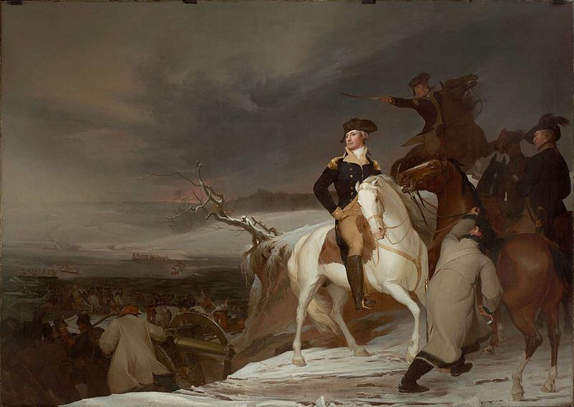

Write a two to three sentence interpretation of this historic painting

They never went to law school
Quote of the Day:
“Actions speak louder than words.”

