Big 3 Warm Up 04/25

Word of the Day:
Artifact • adjective

Definition: a man-made object taken as a whole

Example Sentence: In its present form, the Sanders Cafe and Museum was born in 1990. To mark the birthday of the founder of KFC, it put out a call for artifacts and memorabilia that would allow it to celebrate the Colonel, his cafe and his fried chicken.

Use the word of the day in a sentence and underline the word.

World History/Government Trivia:

According to the U.S. Constitution, no person may become President of the United States unless he/she is a citizen who has lived in this country for at least how many years?

Picture Response:
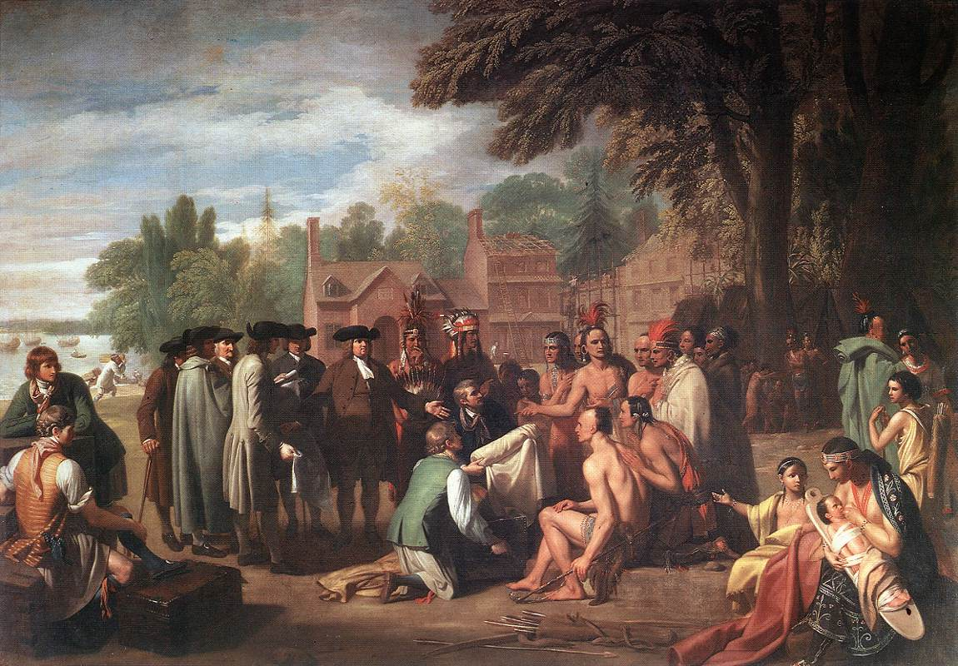

Write a two to three sentence interpretation of this historic painting

Quote of the Day:
“Actions speak louder than words.”

14 YEARS

