Big 3 Warm Up 04/24

Word of the Day:
Zeal\noun:

Definition: Fervor for a person, cause, or object; eager desire or endeavor; enthusiastic diligence; ardor.

Example Sentence: This passionate profession, which Newman uttered with the greater zeal that it was the first time he had felt the relief words at once as hard and as careful as hammer-taps could give his spirit, kindled two small sparks in Mrs. Bread's fixed eyes.

Use the word of the day in a sentence and underline the word.

History/Government Trivia:
What state abolished its personal income tax in 1980 and refunded $185 million already collected to its taxpayers?

Picture Response:
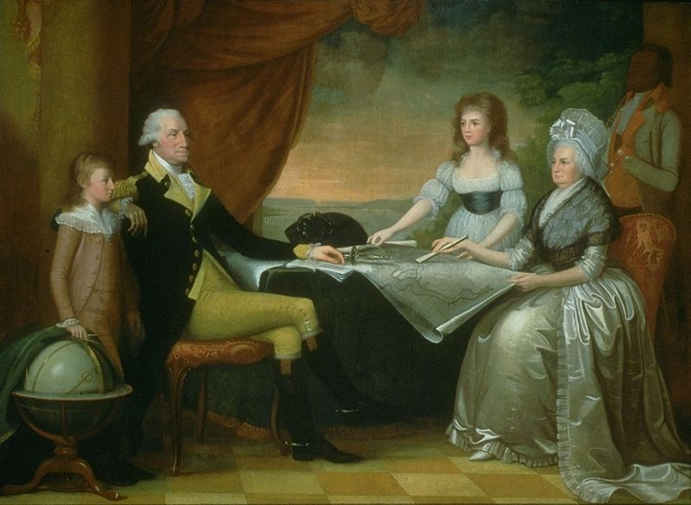

Write a two to three sentence interpretation of this historic painting

Quote of the Year:
“Actions speak louder than words.”

Alaska, which has the highest per capita income in the country

