Big 3 Warm Up 03/11/13

Word of the Day:
Intrepid, adjective:

Definition: Fearless; bold; brave; undaunted; courageous; as, an intrepid soldier; intrepid spirit.

Example Sentence: But the stubborn descendants of the twenty-one intrepid people who plowed through the mountains in search of the sea to the west avoided the reefs of the melodic mix-up and dancing went on until dawn.

Use the word of the day in a sentence and underline the word.

Government Trivia:

Where is it illegal for a portrait of a living person to appear in the United States?

Picture Response:
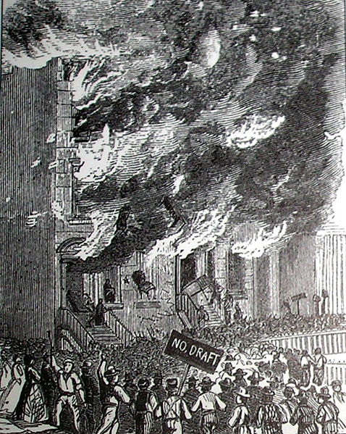

Write a two to three sentence interpretation of this historic painting

Quote of the Day:
“Actions speak louder than words.”

On our postage stamps

