8th Grade Unit Study Guide for Friday’s Exam

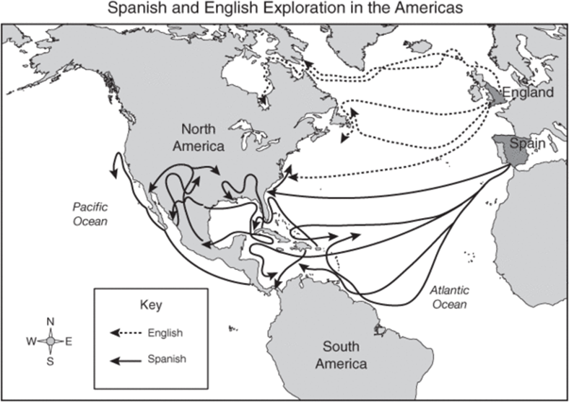
What can be said and interpreted by the map of the 16th century European exploration?

Which colony was founded in Virginia in 1607 and became successful because of alliances with native peoples and growing tobacco as a major crop?

Which 1620 document was signed by male members of the community to establish a government for settlers at Plymouth?

The original 13 English colonies were primarily located along what body of water?

Name the original 13 English Colonies

During the 1700’s and 1800’s, European migration to North America resulted in Native Americans experiencing what type of things and results
Name the major causes of the American Revolution

Who was in charge of all American armed forces during the American Revolution?

The Bill of Rights was added to the U.S. Constitution mainly for what purpose

Name the rights guaranteed by the First Amendment

The “Nineteenth Century” refers to which period of time?

In 1803, Thomas Jefferson made one of his most important contributions as president when he

The combination of resources, improved transportation, and technological breakthroughs all contributed to the

Name some important devices that were invented in the 1800’s

Name the new forms of transportation developed in the 1800’s

What was Manifest Destiny?

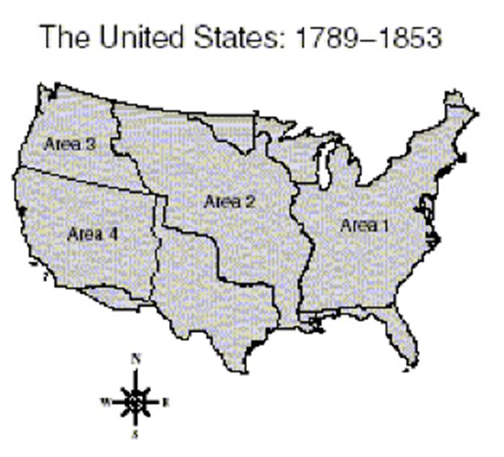
Which area on the map was acquired by the United States as a result of the Mexican War?

Southern dependence on slavery and an agricultural economy resulted in what?

